Keals, Wayne
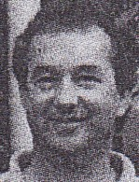
Graduated from Dwellingup Cadet School 1971. Appointed as Forest Guard in training at Manjimup in 1972. Received CALM Certificate of Appreciation, Arbor Day 1999.
Wayne Keals was a senior forester, harvesting, with the Forest Products Commission at Manjimup, in 2002.

